Design Principles and Patterns
Exercise 1: Implementing the Singleton Pattern
using System;
class Logger
{
private static Logger instance;
private Logger()
{
}
public static Logger GetInstance()
{
if (instance == null)
{
instance = new Logger();
}
return instance;
}
public void Log(string message)
{
Console.WriteLine("LOG: " + message);
}
}
class Program
{
static void Main()
{
Logger logger1 = Logger.GetInstance();
Logger logger2 = Logger.GetInstance();
logger1.Log("First Message");
logger2.Log("Second Message");
if (logger1 == logger2)
{
Console.WriteLine("Both objects are same");
}
else
{
Console.WriteLine("Objects are different");
}}}
Output-
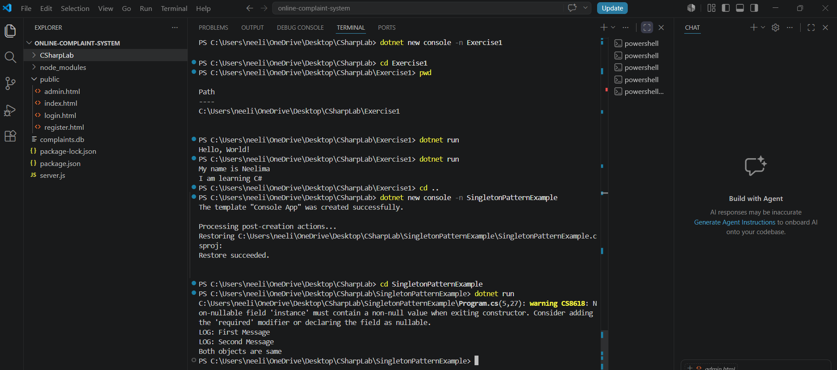
Exercise 2: Implementing the Factory Method Pattern
using System;
interface IDocument
{
void Open();
}
class WordDocument : IDocument
{
public void Open()
{
Console.WriteLine("Opening Word Document");
}}
class PdfDocument : IDocument
{
public void Open()
{
Console.WriteLine("Opening PDF Document");
}}
class ExcelDocument : IDocument
{
public void Open()
{
Console.WriteLine("Opening Excel Document");
}}
abstract class DocumentFactory
{
public abstract IDocument CreateDocument();
}
class WordFactory : DocumentFactory
{
public override IDocument CreateDocument()
{
return new WordDocument();
}}
class PdfFactory : DocumentFactory
{
public override IDocument CreateDocument()
{return new PdfDocument();
}}
class ExcelFactory : DocumentFactory{
public override IDocument CreateDocument() {
return new ExcelDocument();
}}
class Program
{
static void Main()
{
DocumentFactory wordFactory = new WordFactory();
IDocument word = wordFactory.CreateDocument();
word.Open();
DocumentFactory pdfFactory = new PdfFactory();
IDocument pdf = pdfFactory.CreateDocument();
pdf.Open();
DocumentFactory excelFactory = new ExcelFactory();
IDocument excel = excelFactory.CreateDocument();
excel.Open();
}}
Output-

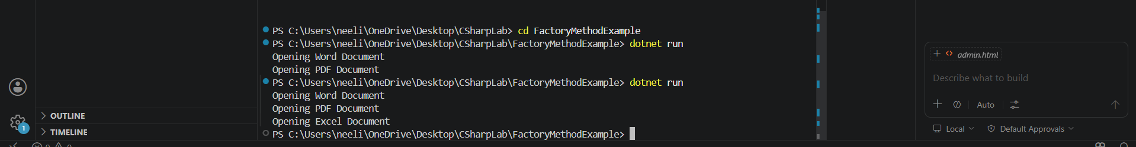
Exercise 3: Implementing the Builder Pattern
using System;
class Computer
{
public string CPU { get; }
public string RAM { get; }
public string Storage { get; }
private Computer(Builder builder)
{
CPU = builder.CPU;
RAM = builder.RAM;
Storage = builder.Storage;
}
public void Display()
{
Console.WriteLine("CPU: " + CPU);
Console.WriteLine("RAM: " + RAM);
Console.WriteLine("Storage: " + Storage);
}
public class Builder
{
public string CPU { get; private set; } = "";
public string RAM { get; private set; } = "";
public string Storage { get; private set; } = "";
public Builder SetCPU(string cpu)
{
CPU = cpu;
return this;
}
public Builder SetRAM(string ram)
{
RAM = ram;
return this;
}
public Builder SetStorage(string storage)
{
Storage = storage;
return this;
}
public Computer Build()
{
return new Computer(this);
}}}
class Program
{
static void Main()
{
Computer gamingPC = new Computer.Builder()
.SetCPU("Intel i9")
.SetRAM("32 GB")
.SetStorage("1000 GB")
.Build();
Computer officePC = new Computer.Builder()
.SetCPU("Intel i5")
.SetRAM("16 GB")
.SetStorage("512 GB")
.Build();
Console.WriteLine("Gaming PC:");
gamingPC.Display();
Console.WriteLine();
Console.WriteLine("Office PC:");
officePC.Display();
}}
Output-
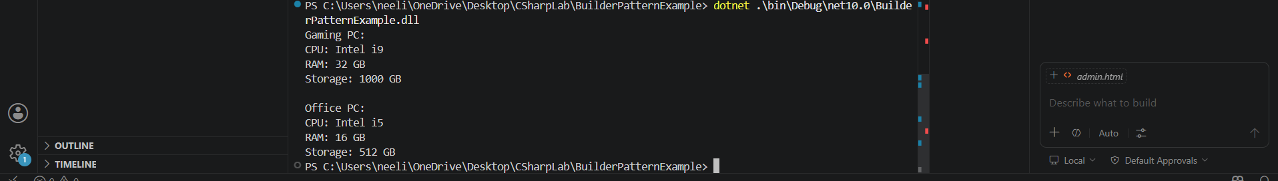
Exercise 4: Implementing the Adapter Pattern
using System;
interface IPaymentProcessor
{
void ProcessPayment(double amount);
}
class PayPalGateway
{
public void SendPayment(double amount)
{
Console.WriteLine("Payment of Rs." + amount + " processed through PayPal.");
}
}
class StripeGateway
{
public void MakePayment(double amount)
{
Console.WriteLine("Payment of Rs." + amount + " processed through Stripe.");
}
}
class PayPalAdapter : IPaymentProcessor
{
private PayPalGateway paypal;
public PayPalAdapter(PayPalGateway paypal)
{
this.paypal = paypal;
}
public void ProcessPayment(double amount)
{
paypal.SendPayment(amount);
}
}
class StripeAdapter : IPaymentProcessor
{
private StripeGateway stripe;
public StripeAdapter(StripeGateway stripe)
{
this.stripe = stripe;
}
public void ProcessPayment(double amount)
{
stripe.MakePayment(amount);
}
}
class Program
{
static void Main()
{
IPaymentProcessor paypal = new PayPalAdapter(new PayPalGateway());
IPaymentProcessor stripe = new StripeAdapter(new StripeGateway());
paypal.ProcessPayment(1000);
stripe.ProcessPayment(2000);
}
}
Output-
Exercise 5: Implementing the Decorator Pattern
using System;
interface INotifier
{
void Send(string message);
}
class EmailNotifier : INotifier
{
public void Send(string message)
{
Console.WriteLine("Email Notification: " + message);
}
}
abstract class NotifierDecorator : INotifier
{
protected INotifier notifier;
public NotifierDecorator(INotifier notifier)
{
this.notifier = notifier;
}
public virtual void Send(string message)
{
notifier.Send(message);
}
}
class SMSNotifierDecorator : NotifierDecorator
{
public SMSNotifierDecorator(INotifier notifier) : base(notifier) { }
public override void Send(string message)
{
base.Send(message);
Console.WriteLine("SMS Notification: " + message);
}
}
class SlackNotifierDecorator : NotifierDecorator
{
public SlackNotifierDecorator(INotifier notifier) : base(notifier) { }
public override void Send(string message)
{
base.Send(message);
Console.WriteLine("Slack Notification: " + message);
}
}
class Program
{
static void Main()
{
INotifier notifier = new EmailNotifier();
notifier = new SMSNotifierDecorator(notifier);
notifier = new SlackNotifierDecorator(notifier);
notifier.Send("Server is Down!");
}
}
Output-
Exercise 6: Implementing the Proxy Pattern
using System;
interface IImage
{
void Display();
}
class RealImage : IImage
{
private string fileName;
public RealImage(string fileName)
{
this.fileName = fileName;
LoadFromServer();
}
private void LoadFromServer()
{
Console.WriteLine("Loading " + fileName + " from remote server...");
}
public void Display()
{
Console.WriteLine("Displaying " + fileName);
}
}
class ProxyImage : IImage
{
private RealImage? realImage;
private string fileName;
public ProxyImage(string fileName)
{
this.fileName = fileName;
}
public void Display()
{
if (realImage == null)
{
realImage = new RealImage(fileName);
}
realImage.Display();
}
}
class Program
{
static void Main()
{
IImage image = new ProxyImage("sample.jpg");
Console.WriteLine("Image created");
image.Display();
Console.WriteLine();
image.Display();
}
}
Output-
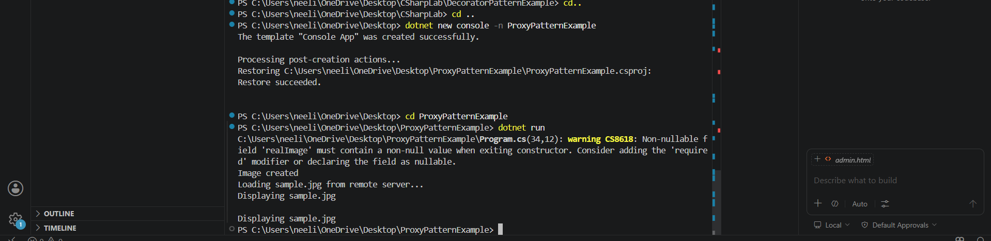
Exercise 7: Implementing the Observer Pattern
using System;
using System.Collections.Generic;
interface IObserver
{
void Update(string stockName, double price);
}
interface IStock
{
void RegisterObserver(IObserver observer);
void RemoveObserver(IObserver observer);
void NotifyObservers();
}
class StockMarket : IStock
{
private List<IObserver> observers = new List<IObserver>();
private string stockName;
private double price;
public StockMarket(string stockName)
{
this.stockName = stockName;
}
public void RegisterObserver(IObserver observer)
{
observers.Add(observer);
}
public void RemoveObserver(IObserver observer)
{
observers.Remove(observer);
}
public void NotifyObservers()
{
foreach (var observer in observers)
{
observer.Update(stockName, price);
}
}
public void SetPrice(double price)
{
this.price = price;
NotifyObservers();
}
}
class MobileApp : IObserver
{
public void Update(string stockName, double price)
{
Console.WriteLine("Mobile App: " + stockName + " price updated to " + price);
}
}
class WebApp : IObserver
{
public void Update(string stockName, double price)
{
Console.WriteLine("Web App: " + stockName + " price updated to " + price);
}
}
class Program
{
static void Main()
{
StockMarket stock = new StockMarket("TCS");
IObserver mobile = new MobileApp();
IObserver web = new WebApp();
stock.RegisterObserver(mobile);
stock.RegisterObserver(web);
stock.SetPrice(3500);
stock.SetPrice(3600);
}
}
Output-
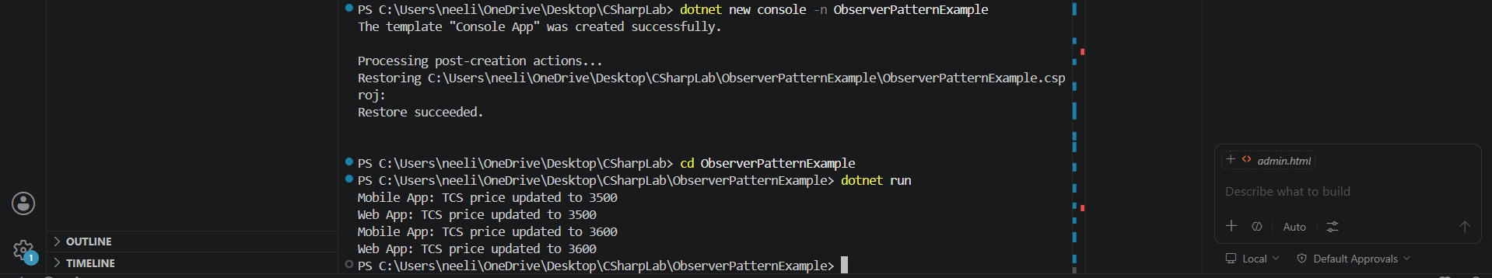
Exercise 8: Implementing the Strategy Pattern
using System;
interface IPaymentStrategy
{
void Pay(double amount);
}
class CreditCardPayment : IPaymentStrategy
{
public void Pay(double amount)
{
Console.WriteLine("Paid Rs." + amount + " using Credit Card");
}
}
class PayPalPayment : IPaymentStrategy
{
public void Pay(double amount)
{
Console.WriteLine("Paid Rs." + amount + " using PayPal");
}}
class PaymentContext
{
private IPaymentStrategy paymentStrategy;
public void SetPaymentStrategy(IPaymentStrategy paymentStrategy)
{
this.paymentStrategy = paymentStrategy;
}
public void ExecutePayment(double amount)
{
paymentStrategy.Pay(amount);
}
}
class Program
{
static void Main()
{
PaymentContext context = new PaymentContext();
context.SetPaymentStrategy(new CreditCardPayment());
context.ExecutePayment(5000);
context.SetPaymentStrategy(new PayPalPayment());
context.ExecutePayment(3000);
}
}
Output-
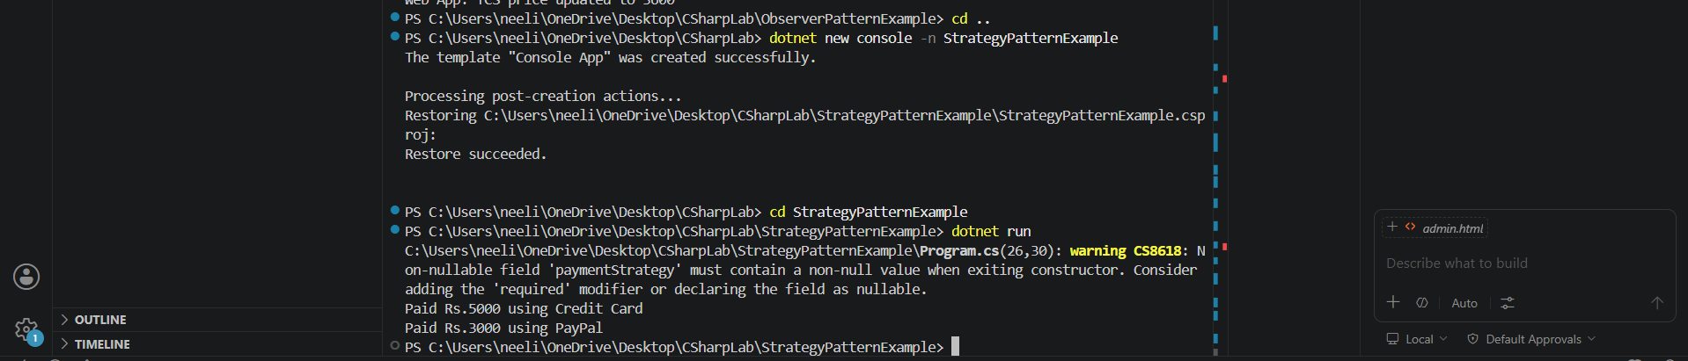
Exercise 9: Implementing the Command Pattern
using System;
interface ICommand
{
void Execute();
}
class Light
{
public void TurnOn()
{
Console.WriteLine("Light is ON");
}
public void TurnOff()
{
Console.WriteLine("Light is OFF");
}
}
class LightOnCommand : ICommand
{
private Light light;
public LightOnCommand(Light light)
{
this.light = light;
}
public void Execute()
{
light.TurnOn();
}
}
class LightOffCommand : ICommand
{
private Light light;
public LightOffCommand(Light light)
{
this.light = light;
}
public void Execute()
{
light.TurnOff();
}
}
class RemoteControl
{
private ICommand command;
public void SetCommand(ICommand command)
{
this.command = command;
}
public void PressButton()
{
command.Execute();
}
}
class Program
{
static void Main()
{
Light light = new Light();
ICommand lightOn = new LightOnCommand(light);
ICommand lightOff = new LightOffCommand(light);
RemoteControl remote = new RemoteControl();
remote.SetCommand(lightOn);
remote.PressButton();
remote.SetCommand(lightOff);
remote.PressButton();
}
}
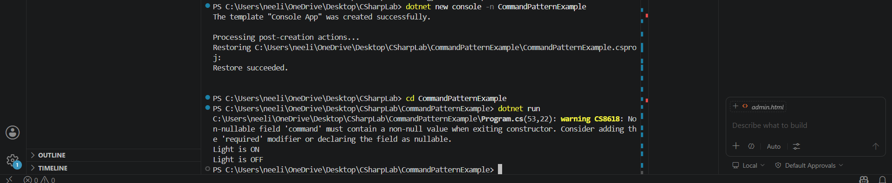
Exercise 10: Implementing the MVC Pattern
using System;
class Student
{
public string Name { get; set; }
public int Id { get; set; }
public string Grade { get; set; }
public Student(string name, int id, string grade)
{
Name = name;
Id = id;
Grade = grade;
}
}class StudentView
{
public void DisplayStudentDetails(string name, int id, string grade)
{
Console.WriteLine("Student Details");
Console.WriteLine("Name: " + name);
Console.WriteLine("ID: " + id);
Console.WriteLine("Grade: " + grade);
}
}
class StudentController
{
private Student model;
private StudentView view;
public StudentController(Student model, StudentView view)
{
this.model = model;
this.view = view;
}
public void SetStudentName(string name)
{
model.Name = name;
}
public string GetStudentName()
{
return model.Name;
}
public void UpdateView()
{ view.DisplayStudentDetails(model.Name, model.Id, model.Grade);
}}
class Program
{
static void Main()
{
Student model = new Student("Neelima", 101, "A");
StudentView view = new StudentView();
StudentController controller = new StudentController(model, view);
controller.UpdateView();
controller.SetStudentName("Bunny");
Console.WriteLine();
controller.UpdateView();
} }
Output-
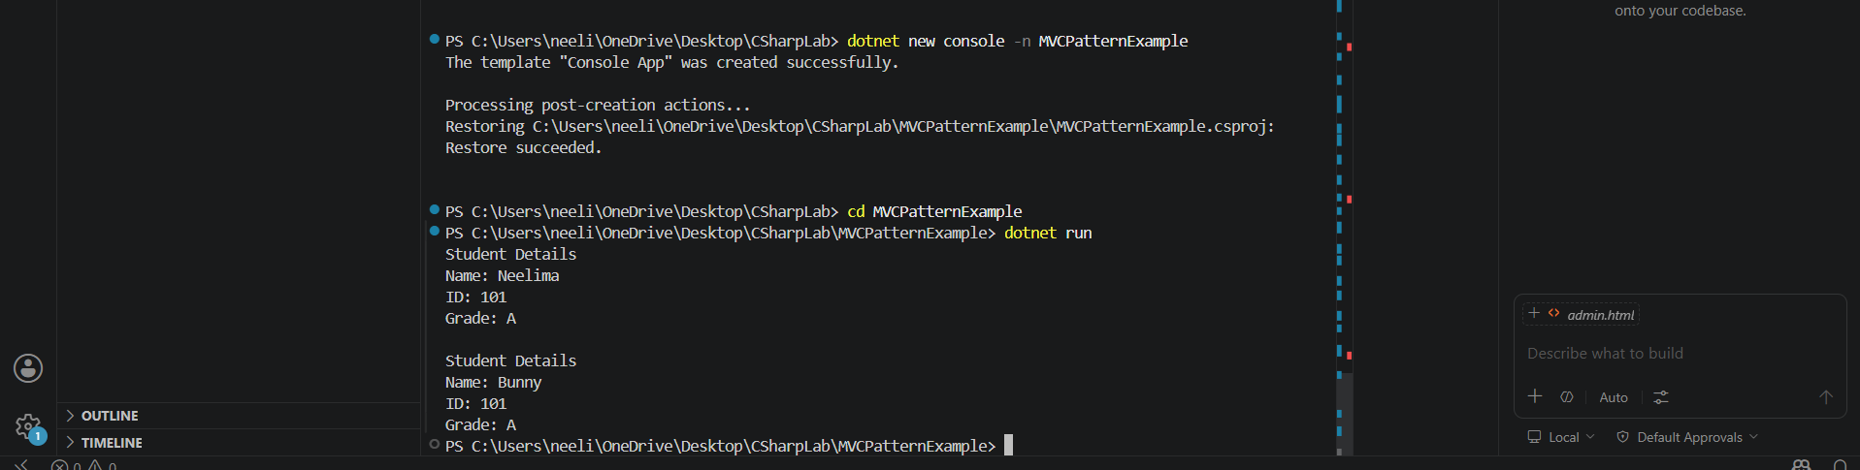
Exercise 11: Implementing Dependency Injection
using System;
interface ICustomerRepository
{
string FindCustomerById(int id);
}
class CustomerRepositoryImpl : ICustomerRepository
{
public string FindCustomerById(int id) {
return "Customer ID: " + id + ", Name: Neelima";
}
}
class CustomerService
{
private ICustomerRepository repository;
public CustomerService(ICustomerRepository repository)
{
this.repository = repository;
}
public void GetCustomer(int id)
{
Console.WriteLine(repository.FindCustomerById(id));
}
}
class Program
{
static void Main()
{
ICustomerRepository repository = new CustomerRepositoryImpl();
CustomerService service = new CustomerService(repository);
service.GetCustomer(101);
}
}
Output-
